**Setting up UAV with Pixhawk**

User Manual-1

Table of Contents

1. Components and Specifications 3

1.1. Pixhawk 2.4.8 Drone Flight Controller 3

1.2. Transmitter and Receiver 4

1.3 Brushless DC motors (Count:4) & HD Propellors (1CW+1CCW – 1 pair) 5

1.4. Brushless Speed Controller ESC (Count:4) 6

1.3. Lithium Polymer (LiPo) battery and B3 AC Compact Balance Charger 6

1.4. Q450 Quadcopter Frame 7

1.5. APM/Pixhawk Power Module 8

2. UAV kit Assembly 8

2.1. ESC and Motor Wiring Description 8

2.2. Quadcopter Frame Assembly 10

3. Flight Control System Configuration 11

3.1. Installing Ground Station (GCS) Software 11

3.2. Loading Firmware 11

3.3. Install Firmware 11

3.4. Frame Class & Type Configuration 13

3.5. Accelerometer Calibration 13

3.6. Compass Calibration 15

3.7. Radio Control Calibration 16

3.8. Flight Modes Configuration 18

3.9. ESC Calibration 19

4. Exercise Programs 19

4.1. Arming and Disarming the motors 19

4.2. First Flight 20

4.3. Some more exercises 20

# Components and Specifications

## Pixhawk 2.4.8 Drone Flight Controller

|  |  |  |
| --- | --- | --- |
| **Pixhawk 2.4.8 Drone Flight Controller (Autopilot)** | | |
| **Make** | Pixhawk | |
| **Model** | PIX 2.4.8 (32-bit) | |
| **Sr No** | **Description** | |
|  | **General Data** | |
| 1 | Processors | * 32-bit ARM Cortex M4 core with FPU * 168 Mhz/256 KB RAM/2 MB Flash * 32-bit failsafe co-processor |
| 2 | Power | * Ideal diode controller with automatic failover * Servo rail high-power (7 V) and high-current ready * All peripheral outputs over-current protected, all inputs ESD protected |
| 3 | Firmware | Mission Planner/ QGroundControl |
| 4 | μSD card support | Yes |
| 5 | Sensors | * 3-Axis Gyro meter * Accelerometer * High-performance Barometer * Magnetometer |
| 6 | Interfaces | * 5x UART serial ports, 1 high-power capable, 2 with HW flow control * Spektrum DSM/DSM2/DSM-X Satellite input * Futaba S.BUS input (output not yet implemented) * PPM sum signal * RSSI (PWM or voltage) input * I2C, SPI, 2x CAN, USB * 3.3V and 6.6V ADC inputs |
| 7 | Connector | Micro-USB Type-B connector for connection to PC during programming and debugging. |

## Transmitter and Receiver

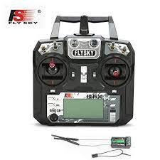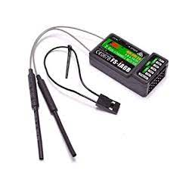

|  |  |  |
| --- | --- | --- |
| **FlySky FS-i6 2.4G 6CH PPM RC Transmitter With FS-iA6B Receiver** | | |
| **Make** | FlySky | |
| **Model** | FS-i6 | |
| **Sr No.** | **General Data** | |
| 1 | Channels | 6 |
| 2 | Model Type | Quadcopter/Glider/Heli/Airplane |
| 3 | RF Range | 2.40-2.48GHz |
| 4 | Bandwidth | 500KHz |
| 5 | Band | 142 |
| 6 | RF Power | Less Than 20dBm |
| 7 | Code Type | GFSK |
| 8 | Sensitivity | 1024 |
| 9 | Low Voltage Warning | Less than 4.2V |
| 10 | DSC Port, Output: | PS2, PPM |
| 11 | Charger Port | No, 4 AA size DC Batteries |
| 12 | Display Mode | Transflective STN positive type, 128*64 dot matrix VA73*39mm, white backlight |
| 13 | Channel Order | Aileron-CH1, Elevator-CH2, Throttle-CH3, Rudder-CH4, Ch 5 & 6 open to assignment to other functions. |

## . Brushless DC motors (Count:4) & HD Propellors (1CW+1CCW – 1 pair)

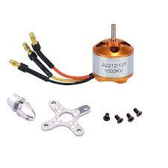

|  |  |  |
| --- | --- | --- |
| **SPECIFICATION FOR BRUSHLESS DC MOTORS** | | |
| **Make** | Robo India | |
| **Model** | A2212 10T 1400KV Brushless Motor for Drone | |
| **Sr No.** | **General Data** | |
| 1 | Supply Voltage | 9V DC |
| 2 | Type | Brushless motor |
| 3 | Motor KV (RPM/V) | 1000 |
| 4 | Max Efficiency | 80% |
| 5 | Compatible LiPo Battery | 2S-3S |
| 6 | Max Efficiency Current | 4-10A (>75%) |
| 7 | No Load Current | 0.5A@10V |
| 8 | Max Current | 13A for 60S |
| 9 | Max Watts | 150W |
| 10 | Poles | 14 |

## Brushless Speed Controller ESC (Count:4)

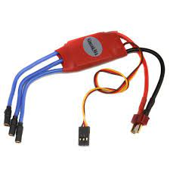

|  |  |  |
| --- | --- | --- |
| **ESC SPECIFICATIONS** | | |
| **Make** | SimonK | |
| **Model** | 30A Brushless Speed Controller ESC | |
| **Sr No.** | **General Data** | |
|  | Current | 30A |
|  | Burst Current | 40A |
|  | Voltage Range | 4V – 16.8V |
|  | BEC Output | Yes (5V/2A) |
|  | Suitable LiPo Batteries | 2S-3S |
|  | Size | 32mm x 24mm x 7mm |

## Lithium Polymer (LiPo) battery and B3 AC Compact Balance Charger

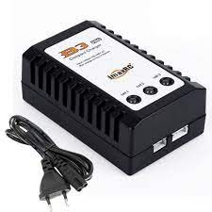

|  |  |  |
| --- | --- | --- |
| **Orange 5200mAh 3S 40C/80C Lithium polymer battery Pack (LiPo)** | | |
| **Sr No** | **Description** | |
|  | **Li-Po Battery** | |
| 1 | Model No. | Orange 5200mAh 3S 40C/80C |
| 2 | Rechargeable | Yes |
| 3 | Capacity | 5200mAh |
| 4 | Voltage | 11.2V |
| 5 | Max Continuous Discharge | 40C (208.0A) |
| 6 | Balance Plug | JST-XH |
| 7 | Discharge Plug | XT-60 |
| 8 | Charging Rate | 1-3C Recommended, 5C Max |
|  |  |  |

## Q450 Quadcopter Frame

|  |
| --- |
| **SPECIFICATIONS** |
| * Materials: glass fibre + polyamide nylon * Frame Weight: 280g. * Height: 55mm * Coloured arms for orientation to keep you flying in the right direction. * Power distribution board included (inbuilt PCB). * Pre-threaded brass sleeves for all frame bolts. * Large mounting tabs on main frame bottom plate for easy camera mounting. |

## APM/Pixhawk Power Module

|  |  |  |
| --- | --- | --- |
| **POWER MODULE SPECIFICATIONS** | | |
| **Make** | - | |
| **Model** | Power Module V6.0 Output BEC 3A XT60 Plug 28V 90A | |
| **Sr No** | **Description** | |
|  | **General Data** | |
| 1 | Connector type | XT60 |
| 2 | Voltage and Current Measurements | Configured for 5V ADC |
| 3 | Switching Regulator | 5.3V and 3A (max) |
| 4 | Connectors | 6-pos DF13 cable plugs directly to APM 2.5’s ‘PM’ connector. |
| 5 | Suitable LiPo Batteries | 2S-6S |

# UAV kit Assembly

## ESC and Motor Wiring Description

* Step 1: Solder the bottom board as follows. Solder the Silicon wires according to the polarity at connecting points located at the corners of the board (Note: There wires should not be too long). These would supply power from the battery to the motors via ESCs. Connect the XT60 Male w/ 14AWG Silicon Wire at the connecting point located on the side of the board. This point is where the battery distributes power over the board.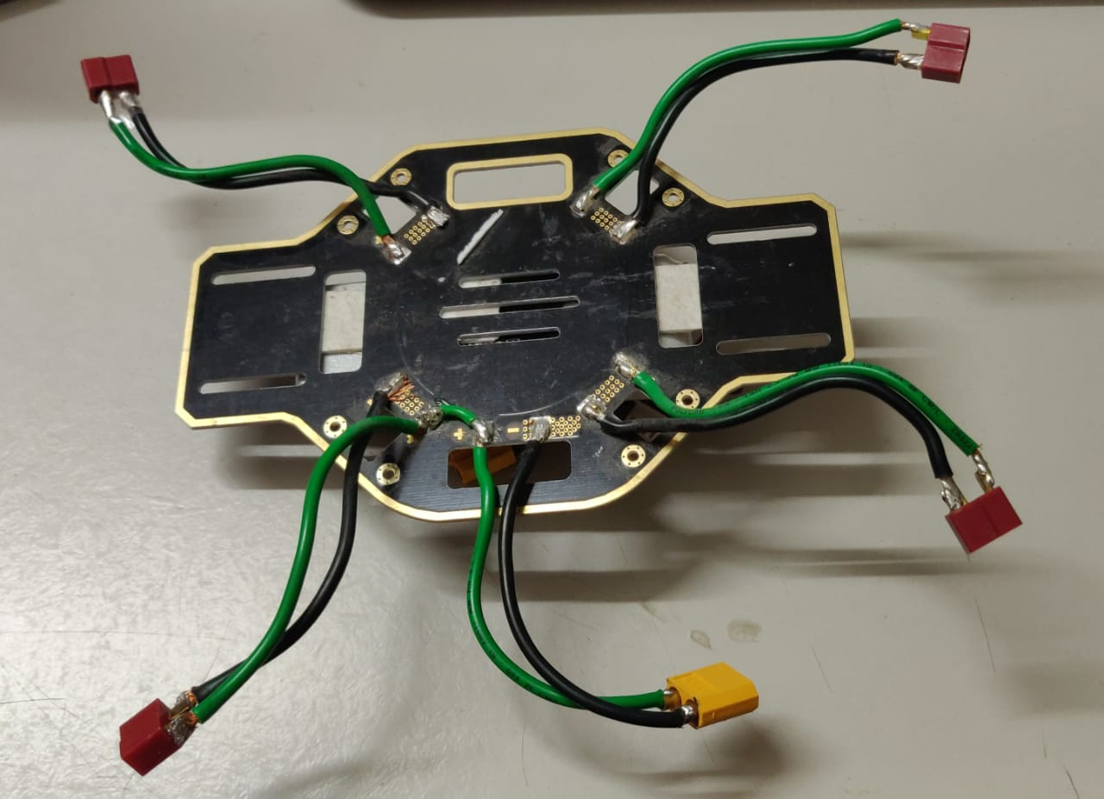
* Step 2: Connect each ESC to the power pads on the bottom board as shown in the figure below, via the maroon connectors (avoid soldering the ESCs directly to the bottom board). Make sure that the soldering on the bottom board is perfect and there is no possibility for a short circuit. The red wire of the coaxial power cable of each ESC is positive, while the black wire is negative. Make sure to connect them correctly with respect to their polarities.

* Step 3: Connect the signal cable to your controller (Pixhawk). The orange wire of the signal cable is for the control signal, while the brown wire is of the signal cable is for the GND.
* Step 4: Connect the motor to the ESC. The middle cable of the ESC is to be connected to the yellow cable of the motor. Connect the Red and Black cables of the motor arbitrarily with the remaining two cables of ESC. Later, when testing the motor during ESC calibration, if the direction of rotation doesn’t match, switch the position of the red and black cables.

## Quadcopter Frame Assembly

* Step 1: Install the bottom and top boards with arms between them. Note to install the screws with appropriate force to prevent breaking threads. Note that arms ①② point to the nose of the UAV, while arms ③④ point to the tail. It is recommended to choose the same colour arms for the same direction. See from top, motors on arms ①③ rotate counter-clockwise and motors on arms ②④ rotate clockwise.
* Step 2: Install your flight controller system and electronic system. The flight controller (Pixhawk) must be placed (stuck with double-sided tape) on the top of the top board. Install ESCs and motors. Use four M3x8 screws to attach the motors.
* Step 3: Tidy all Cables. Make sure all cables are not cut by the frame boards and propellers. Use nylon cable zip ties to fix the hanging wires/ESC to the arms.
* Step 4: Install the propellers. **Please install the propellers only after flight control system configuration procedure as described in the upcoming section.** Make sure the rotation direction of the propellers is same as the figure shows. Tighten the propeller by rotating it in the lock direction. Do not use any thread lock.

# Flight Control System Configuration

## Installing Ground Station (GCS) Software

* [Mission Planner](https://ardupilot.org/planner/index.html#home) (Windows, Linux, Android): [Install Mission Planner](https://ardupilot.org/planner/docs/mission-planner-installation.html#install-mission-planner). This GCS is the most compatible and closely tracks new features and updates in ArduPilot. It is recommended for first-time users and power users alike. It functions best in the Windows environment.
* Mission Planner was designed for native Windows installation. However, it is possible to use it under Linux (with some occasional issues) and there is a Beta version for Android OS. Refer to this [link](https://ardupilot.org/planner/docs/mission-planner-installation.html#install-mission-planner) for installation.

## Loading Firmware

* **Connect autopilot to computer:** Once you have installed a ground station on your computer, connect the autopilot using the micro USB cable as shown below. Use a direct USB port on your computer (not a USB hub). Windows should automatically detect and install the correct driver software.
* **Select the COM port:** If using Mission Planner as the GCS, select the COM port drop-down in the upper-right corner of the window near the Connect button. Select AUTO or the specific port for your board. Set the Baud rate to 115200 as shown. Do not hit Connect just yet.

## Install Firmware

* In Mission Planner’s **SETUP | Install Firmware** screen select the appropriate icon that matches your frame (i.e. Quad). Answer Yes when it asks you “Are you sure?”.

* Mission Planner will try to detect which board you are using. It may ask you to unplug the board, press OK, and plug it back in to detect the board type

* If all goes well, you will see a status appear on the bottom right including the words: “erase…”, “program…”, “verify..”, and “Upload Done”. The firmware has been successfully uploaded to the board.
* It usually takes a few seconds for the bootloader to exit and enter the main code after programming or a power-up. Wait to press CONNECT until this occurs.

## Frame Class & Type Configuration

* Select **Initial Setup,** **Mandatory Hardware | Frame Type**.

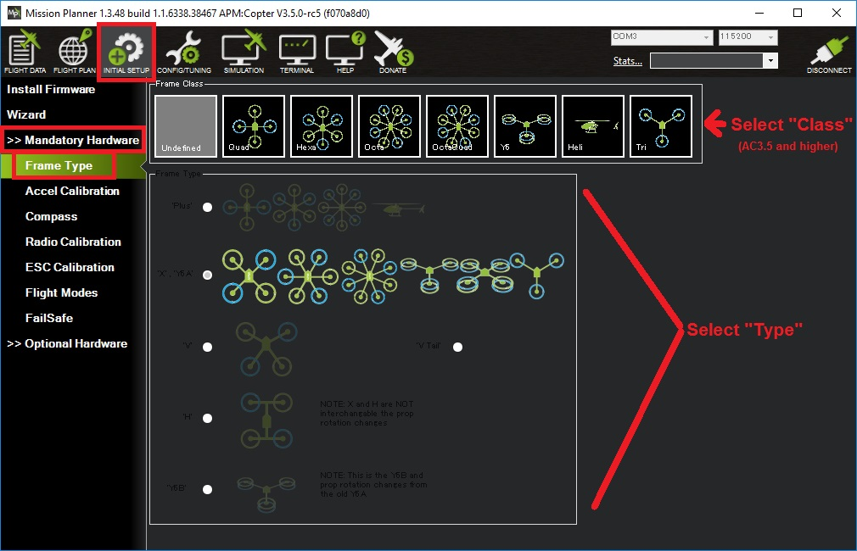

* Select the second option: **‘X’,’Y6A’** for the quadcopter.

## Accelerometer Calibration

* The accelerometers in the autopilot must be calibrated to correct for their bias offsets in all three axes, as well as any off-axis variations.
* Under **Setup | Mandatory Hardware**, select **Accel Calibration** from the left-side menu.

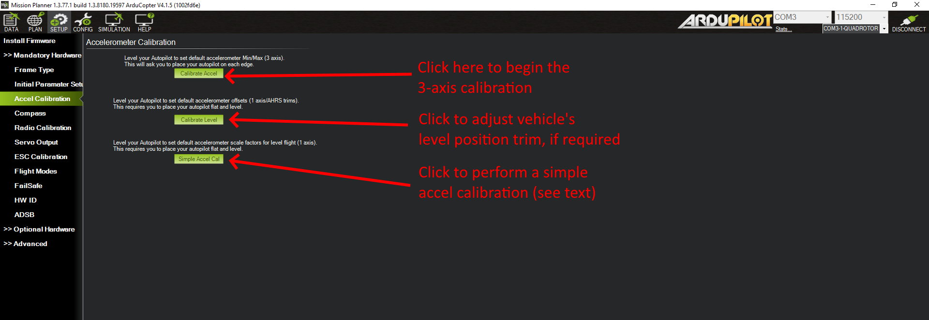

* Click Calibrate Accel to start the full 3-axis calibration.
  + Mission Planner will prompt you to place the vehicle each calibration position. Press any key to indicate that the autopilot is in position and then proceed to the next orientation.
  + The calibration positions are: level, on right side, left side, nose down, nose up and on its back.
* It is important that the vehicle is kept still immediately after pressing the key for each step. This is more important than getting the angle exactly right, i.e. left being 90deg to horizontal, etc. Except for the first “LEVEL”, the positions can be within 20 degs of being exact. **Being still in each position as you press the key is much more important.**
* Proceed through the required positions, using the Click when Done button once each position is reached and held still. When you have completed the calibration process, Mission Planner will display “Calibration Successful!” as shown below.

* The level position is the most important to get right as this will be the altitude that your controller considers level while flying. You can recalibrate this Level position using Mission Planner, after you have installed the flight controller and are ready to fly. Use the Calibrate Level button to do this, holding the vehicle in its level flying attitude.
* (**Optional**) Sometimes, for very large vehicles, it is not easy to do the full 3-axis calibration. In this case, the Simple Accel Cal can be done with the vehicle held still and in level attitude. This only calibrates the main offsets of the accelerometers, not the minor off-axis variations, so it is not ideal in terms of optimal performance but is sometimes an acceptable compromise.

## Compass Calibration

* Under **SETUP| Mandatory Hardware** select **Compass**

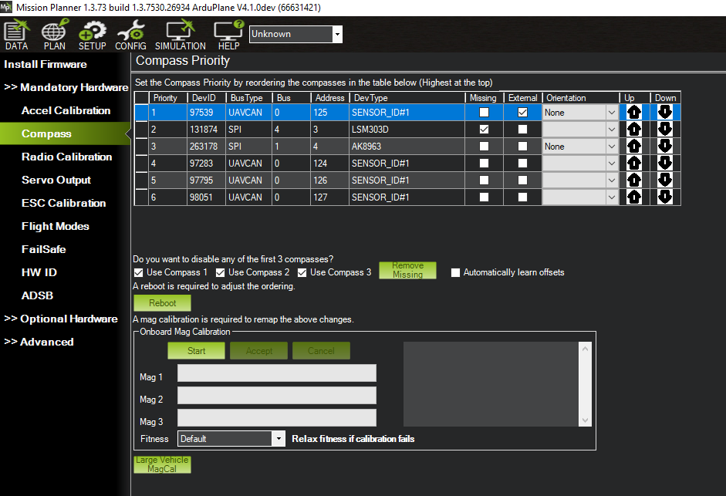

* You may wish to disable any internal compasses if you are consistently seeing the “inconsistent compasses” pre-arm message often and you are sure that the external compass is calibrated.
* To perform the onboard calibration of all compasses:
  + Click the “Onboard Mag Calibration” section’s “Start” button
  + If your autopilot has a buzzer attached you should hear a single tone followed by short beep once per second
  + Hold the vehicle in the air and rotate it so that each side (front, back, left, right, top and bottom) points down towards the earth for a few seconds in turn. Consider a full 360-degree turn with each turn pointing a different direction of the vehicle to the ground. It will result in 6 full turns plus possibly some additional time and turns to confirm the calibration or retry if it initially does not pass.
  + as the vehicle is rotated the green bars should extend further and further to the right until the calibration completes
  + upon successful completion three rising tones will be emitted and a “Please reboot the autopilot” window will appear and you will need to reboot the autopilot before it is possible to arm the vehicle.

## Radio Control Calibration

RC transmitters allow the pilot to set the flight mode, control the vehicle’s movement and orientation and turn on/off auxiliary functions (i.e., raising and lowering landing gear, etc).

RC Calibration involves capturing each RC input channel’s minimum, maximum and “trim” values so that flight controller can correctly interpret the input.

**Calibration:**

* Ensure the battery is disconnected (this is important because it is possible to accidentally arm the vehicle during the RC calibration process)
* Ensure the RC receiver is connected to the autopilot via Futaba style servo cable. Connect Channel 1 of the Receiver to RC IN port of the flight controller, as shown below. Ensure that same wire is attached on the side of the latches on both devices as highlighted in red.

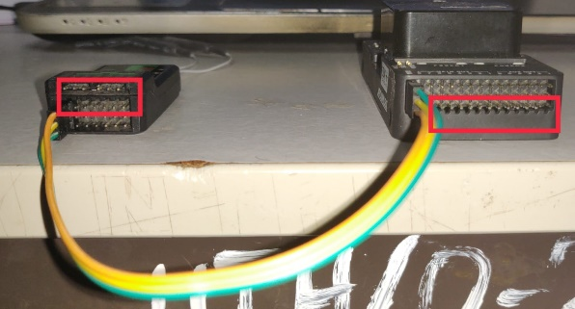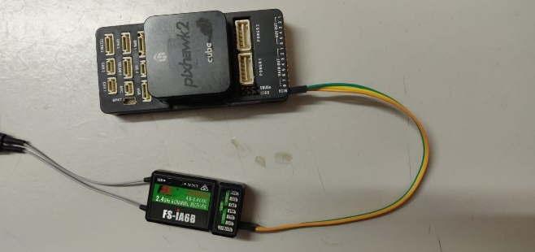

* Connect the autopilot to the PC using a USB cable and turn on your RC transmitter. Long press the “OK” key on the transmitter, go to: System setup -> RX setup -> PPM Output, and make sure it is “ON”.
* On the Mission Planner press the “Connect” button and open Mission Planner’s **INITIAL SETUP | Mandatory Hardware | Radio Calibration** screen
* Some green bars should appear showing the ArduPilot is receiving input from the Transmitter/Receiver. If no bars appear check the receiver’s LED:
  + No lights may indicate that it is incorrectly wired to the autopilot. Look for connectors that may have been inserted upside down.
  + A Red or flashing LED may indicate that your RC transmitter and receiver need to be bound. See the manual that came with your RC equipment for instructions.

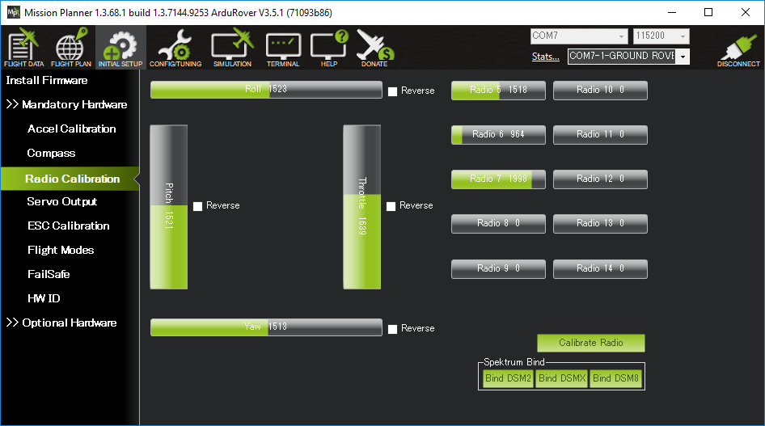

* Click on the green “Calibrate Radio” button on the bottom right
* Press “OK” when prompted to check the radio control equipment is on, battery is not connected, and propellers are not attached.
* Move the transmitter’s control sticks, knobs and switches to their limits. Red lines will appear across the calibration bars to show minimum and maximum values seen so far.

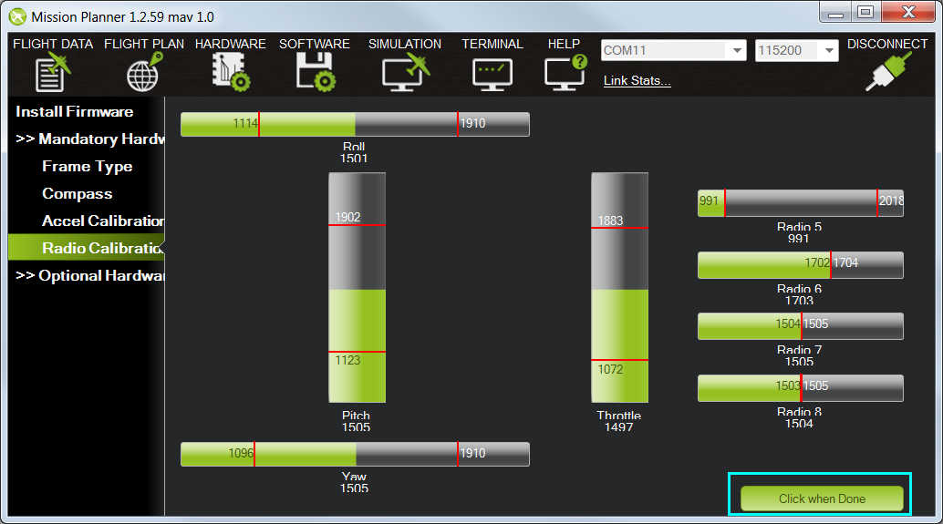

* Select Click when Done
* A window will appear with the prompt, “Ensure all your sticks are centered and throttle is down and click ok to continue”. Move the throttle to zero and press “OK”.
* Mission Planner will show a summary of the calibration data. Normal values are around 1100 for minimums and 1900 for maximums.

**Channel mappings**

Copter default channel mappings are:

* Channel 1: Roll
* Channel 2: Pitch
* Channel 3: Throttle
* Channel 4: Yaw
* Channel 5: Flight modes
* Channel 6: (Optional) Inflight tuning or camera mount (mapped to transmitter tuning knob)
* Channel 7 to 12: (Optional) Auxiliary function switches

## Flight Modes Configuration

* Go to the **Initial Setup | Mandatory Hardware | Flight Modes** screen. Ensure that your transmitter is ON.
* Use the drop-down on each line to select the flight mode for that switch position.
* Set up modes according to the image shown below:

* When you play with the switch SWC on your transmitter, you should be able to see the corresponding flight modes it points to on the screen.
* Since the first task is to manually pilot the UAV, we shall ensure our first mode is “stabilize”. For more information on different available modes, check out this [link](https://ardupilot.org/copter/docs/flight-modes.html).

(Note: Many of the modes require GPS setup).

## ESC Calibration

Electronic speed controllers are responsible for spinning the motors at the speed requested by the autopilot. Most ESCs need to be calibrated so that they know the minimum and maximum pwm values that the flight controller will send.

There are multiple methods of ESC calibration. However, the most versatile method that works with all kinds of ESCs and flight controllers is the “Manual ESC-by-ESC Calibration”.

**Safety Check!** Before calibrating ESCs, please ensure that your copter has NO PROPS on it and that the autopilot is NOT CONNECTED to your computer via USB and the Lipo battery is disconnected.

**Manual ESC-by-ESC calibration:**

1. Plug one of your ESC three-wire cables into the throttle channel of the RC receiver. (This is usually channel 3.)
2. Turn on the transmitter and set throttle stick to maximum (full up).
3. Connect the LiPo battery
4. You will hear a musical tone then two beeps.
5. After the two beeps, lower the throttle stick to full down.
6. You will then hear several beeps (one for each battery cell you’re using) and finally a single long beep indicating the endpoints have been set and the ESC is calibrated. If you now move the throttle up, motors should be running.
7. Disconnect battery. Repeat these steps for all ESCs.
8. If it appears that the ESCs did not calibrate then the throttle channel on the transmitter might need to be reversed.
9. If you are still having trouble after trying these methods (for example, ESCs still beep continuously) try lowering your throttle trim by 50%.
10. You can also try powering your ArduPilot board via the USB first to boot it up before plugging in the LiPo.

# Exercise Programs

## Arming and Disarming the motors

Arming the vehicle allows the motors to start spinning. Before arming, make sure all people, objects, and any body parts (e.g., hands) are clear of the propellers. Make sure correct propellors are fixed tight to the motors. Then do the following:

**Arming the Motors:**

* Turn on your transmitter.
* Plug in the LiPo battery. The red and blue lights should flash for a few seconds as the gyros are calibrated (do not move the copter)
* The pre-arm checks will run automatically and if any problems are found the RGB LED will blink yellow, and the failure will be displayed on the ground station. Please refer to this page
* Check that your flight mode switch is set to Stabilize.
* If using an autopilot with a safety switch, press it until the light goes solid
* Arm the motors by holding the throttle down, and rudder right for 5 seconds. Do not hold the rudder right for too long (>15 seconds) or you will begin the AutoTrim feature
* Once armed, the LEDs will go solid, and the propellers will begin to spin.
* Raise the throttle to take-off.

**Disarming the Motors:**

* Check that your flight mode switch is set to Stabilize.
* Hold throttle at minimum and rudder to the left for 2 seconds
* The LED will start flashing indicating the vehicle is disarmed
* If using a autopilot with a safety switch, press it until the LED begins flashing
* Disconnect the LiPo battery.
* Turn off your transmitter.

## First Flight

**Tips:**

* Make sure you are in a wind free environment (wind will play against you on in air auto trim).
* Make sure you have no trim on your Radio (the autopilot is what we want to trim, the radio should never get trimmed).
* Hold the copter still and level after connecting the battery to allow the gyroscopes to initialize.
* Get above ground effect, around 3-4 feet is enough on most models.
* We recommend not starting in Simple mode. Begin your flying in the basic Stabilize mode.

## Some more exercises

### Connect the GPS module to the drone. Open Mission Planner and try to get GPS lock.

### Assign the Arming and Disarming Function to switch A (SWA) of the RC Transmitter.